**In order to receive credit for your answer, you MUST show ALL work**

Fractions Write each fraction in simplest form.

- $\frac{5}{15}$

- $\frac{1}{6}$

- $\frac{8}{12}$

- $\frac{12}{20}$

Words and Symbols Write the phrase as an algebraic expression.
- 3 more runs than the Pirates scored

- a number decreased by eight

- ten dollars more than Grace has

One Step Equation

- 8 + w = 17

- 6 = 3y

- d – 12 = 5

- 7 ÷ c = 7

- a + 8 = 23

- 10 = 45 – n

Order of Operations

- 54 ÷ (6 + 3)

- (10 + 50) ÷ 5

16.18 + 2(4 - 1)

Exponents Evaluate each expression.

17.$2^{4}$

18. $3^{3}$

19. $4^{2}$
Angle Measures Use a protractor to measure each angle.
20. 40⁰ 145⁰ 90⁰

Integer Operations
21. 5 (-10)

22. -9(-4)

23. -5²

Multiply Decimals Find Each Product
24. 300 x 0.02 x 8

25. 85 x 0.25 x 3

26. Write 4 • 4 • 4• 4 in exponential form.

27. Find the area of each triangle
Base: 35 in.
Height: 10 in.

28. base: 3.2 yd.
Height: 4.2 yd.

Decimals & Percents Write each decimal as a percent
29. 0.675

30. 0.725
Identify each part of the expression as a term, like terms, constant, or coefficient.
31. -4x + 12 + x

32. 2 + 3a + 9a

33. 7 – 5x + 1

34. Write 7x – 2 – 7x + 6 in simplest form.

Rational Numbers- Multiply and Divide Fractions

35. $-\frac{7}{8}$ x $(-\frac{8}{7} )$

36. -6$\frac{2}{5}$ • (-$\frac{5}{32}$ )

37. 6 ÷ ( $-\frac{1}{2}$)

38. Kevin is organizing his movie collection. If each movie case is $\frac{3}{4}$ inch wide, how many movies can fit on a shelf 5$\frac{1}{4}$ feet wide?

Use the Percent Proportion

Type Example Proportion
Find the Percent What percent of 5 is 4? $\frac{4}{5}$ = $\frac{n}{100}$
Find the Part What number is 80% of 5? $\frac{p}{5}$ = $\frac{80}{100}$
Find the Whole 4 is 80% of what number ? $\frac{4}{w}$ = $\frac{80}{100}$

38. What percent of 60 is 15?

39. What number is 15% of 60?

40. 9 is 12% of which number?

41. 12% of 72 is what number?

42. What percent of 50 is 18?

43. A pair of sneakers is on sale as shown. This is 75% of the original price. What was the original price of the sneakers? 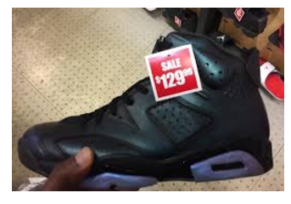

44. Of the 60 bookes on a bookshelf, 24 are nonfiction. What percent of the books are nonfiction?

45. Roman has 2 red pencils in his backpack. If this is 25% of the total number of pencils, how many pencils are in his backpack? Explain.

46. Find the surface of the following figure.
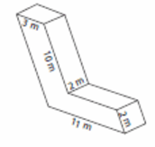
47. Find the surface area of the following net.
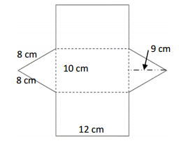
Probability
48. A six sided number cube is rolled once. What is the probability of landing on a multiple of 2?. Write the probability as a fraction, percent, and decimal.

49. A coin is tossed. Find the probability of the coin landing on heads? Write your answer as a fraction, percent, and decimal.

50. A spinner is divided into eight equal sections numbered 1-8. Find the probability of not spinning a 5. Write your answer as a fraction, percent, and decimal.

Honors Mathematics:
You are to create a well-developed essay about math. The essay should be neatly written (in pencil) or typed using 12 point, Times New Roman font. The essay should be at least 1 -2 pages in length. Do not skip lines. In composing your essay, respond to the following questions:
1) Why do you think it is important to be proficient in math?
2) What are your strengths and weaknesses in math?
3) How do you plan on improving your weaknesses and reinforcing your strengths?
4) What are your aspirations and expectations for 7th grade math?

